How to Sign-In to Google Classroom at Home

- Open up web-browser (Google Chrome, Microsoft Edge, etc.)
- Go to classroom.google.com
- Hover over Sign-in and Click on Google Classroom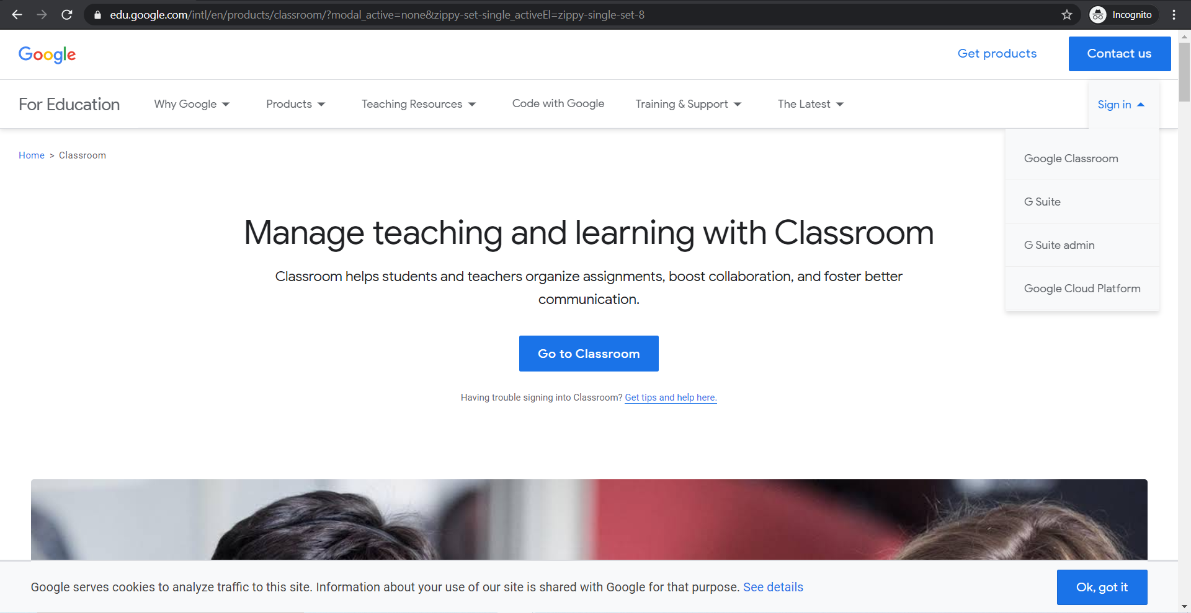
- Sign-in using your school email:
User Name: first three letters of first name last name @sputstudents.org*
Ex. firlast@sputstudents.org
Password: lunch number
*Students must type the @sputstudents.org in order to log in at home!
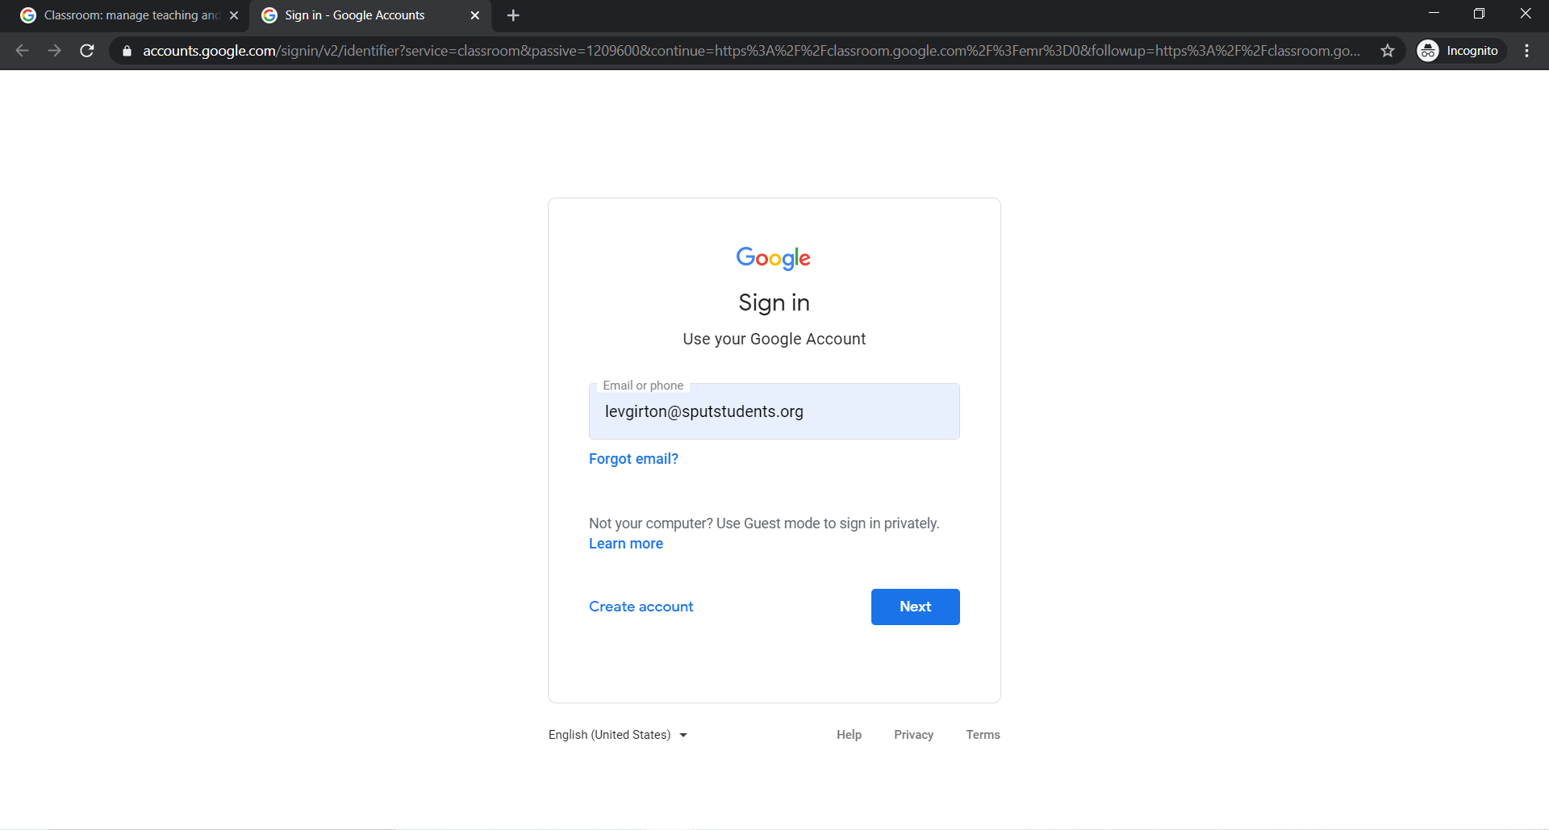

- Students should not at this point be on the Google Classroom homepage
If Students are not able on the classroom homepage,
- Click on the nine dots in the upper right hand corner
- Select the Google Classroom Icon
